**Web skills Assignment (Front-end Mentor Challenge)**

1. Home screen:

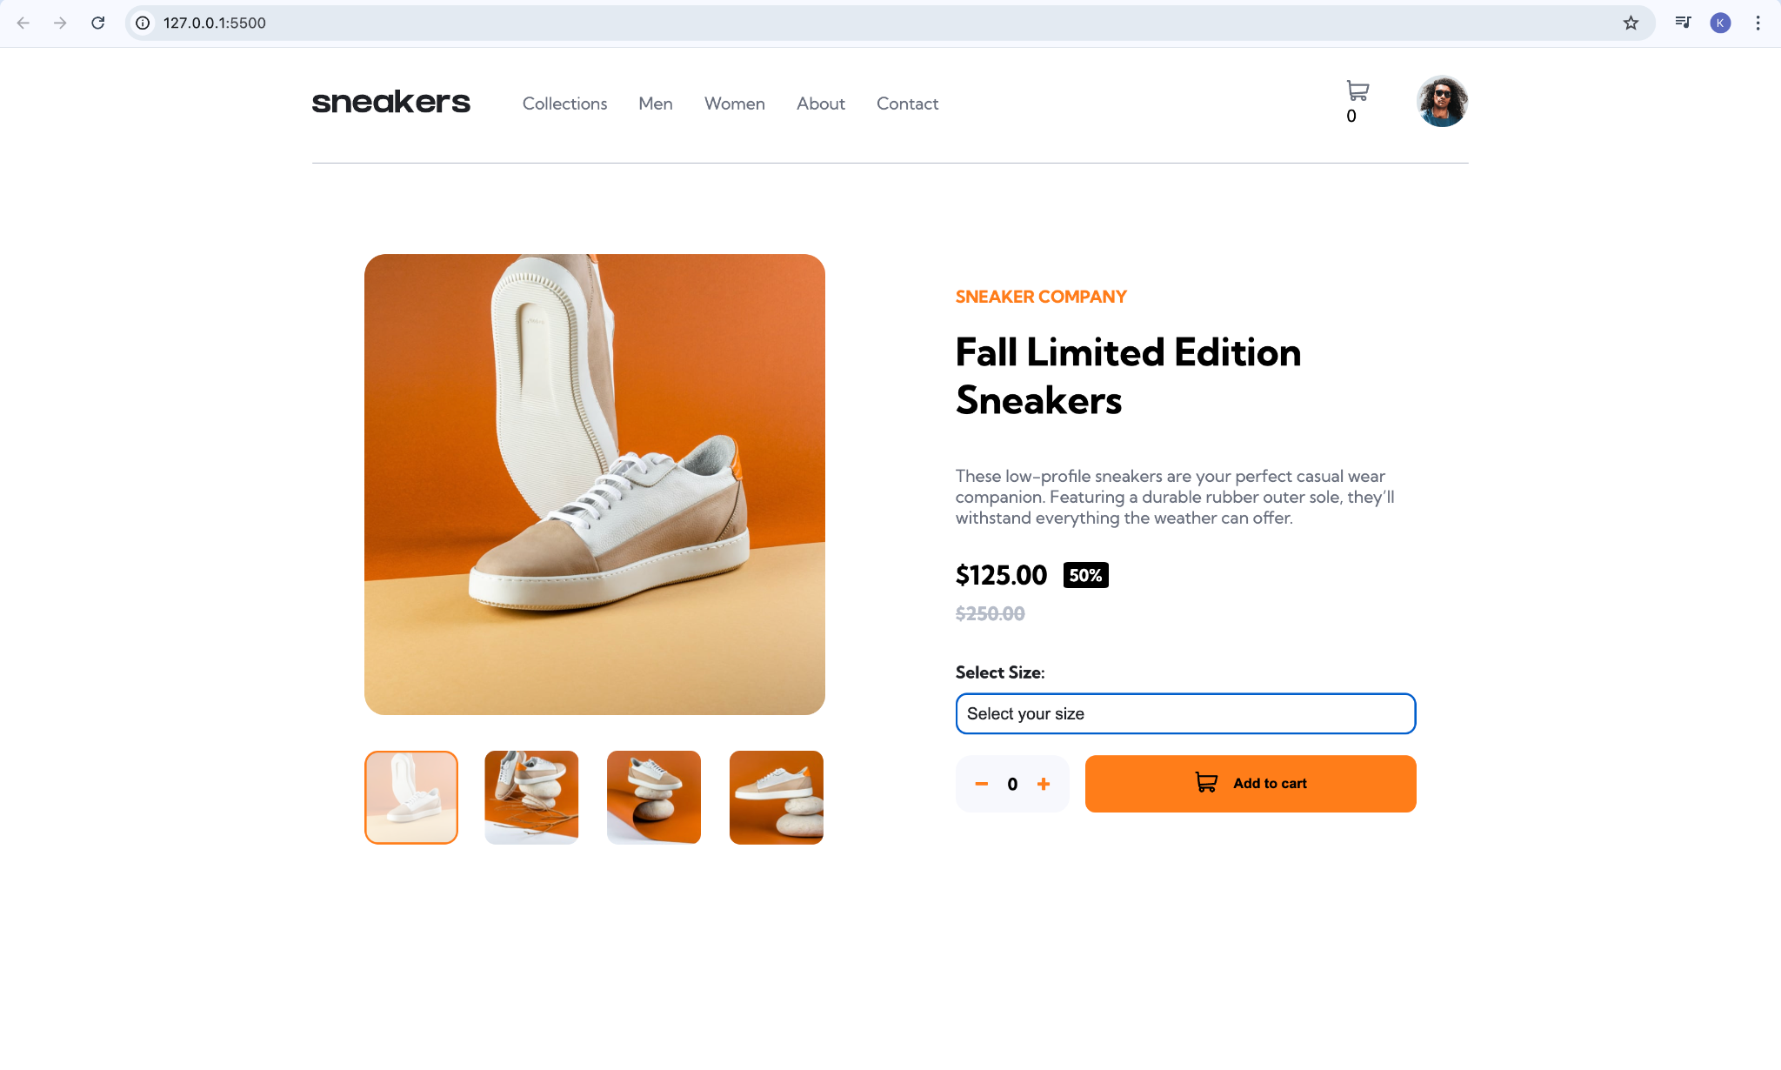

1. Selecting shoe size as needed: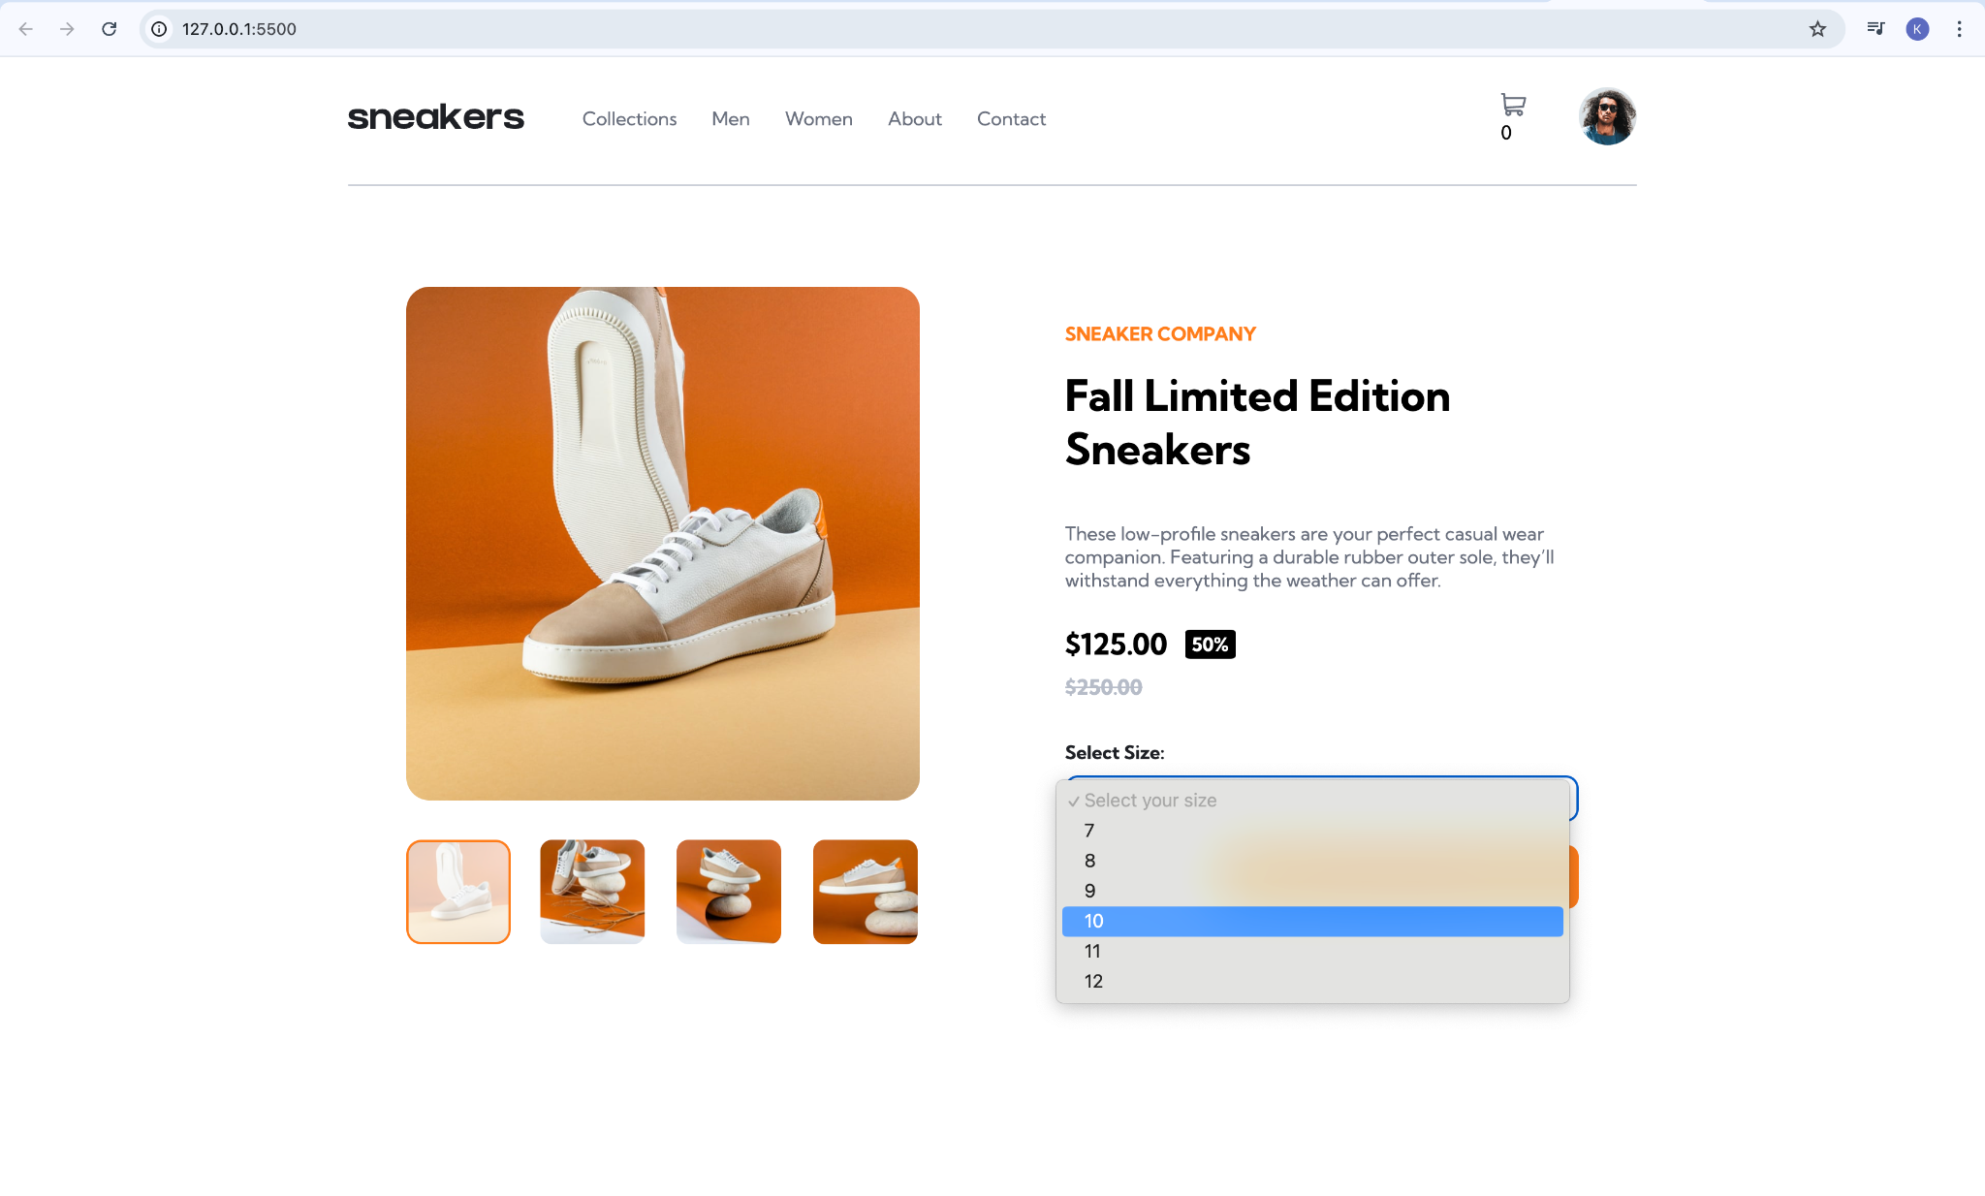
2. Selecting the number of shoes needed:

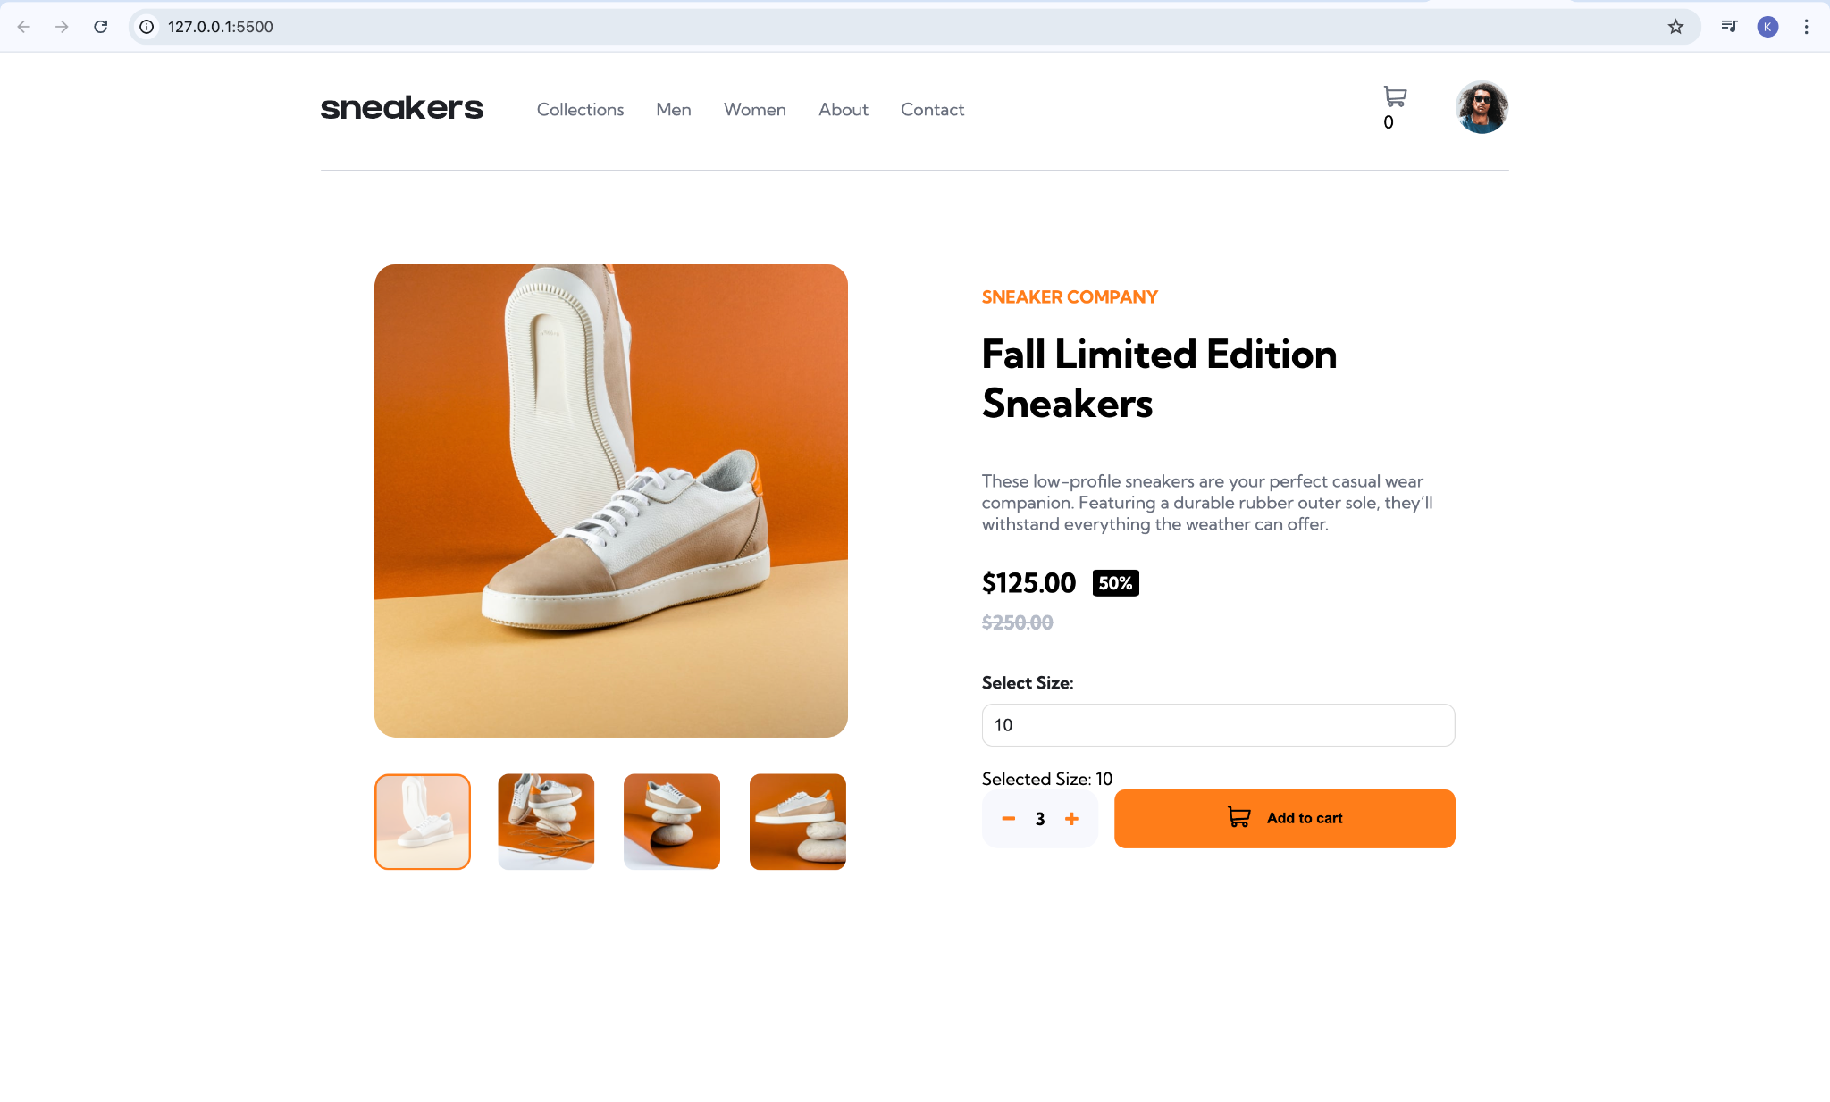

1. Adding them to the cart:

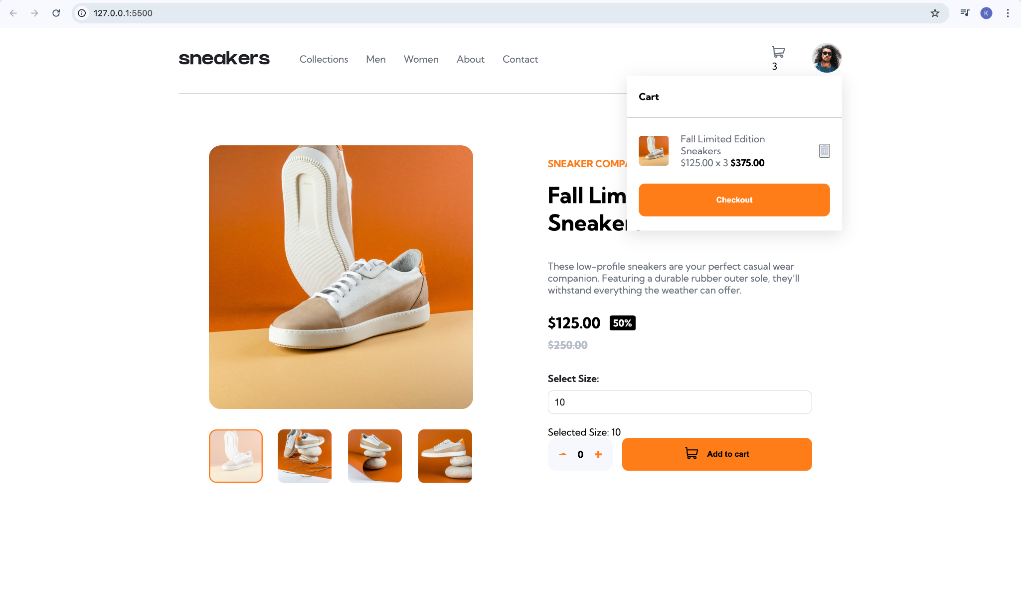

5. Empty cart by clicking on the delete icon:

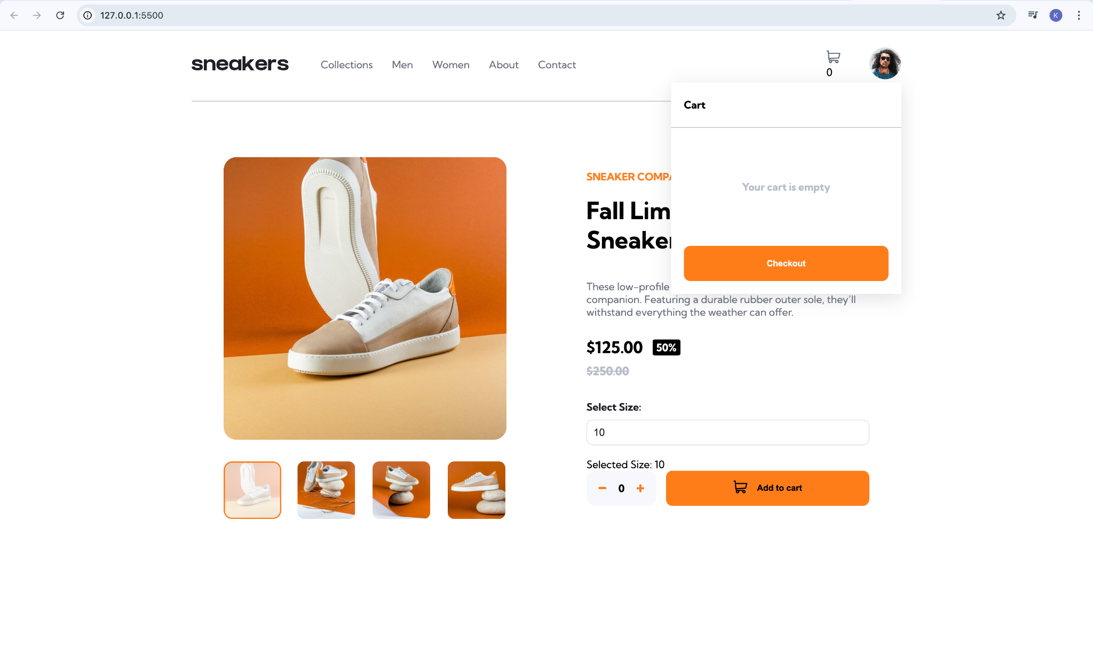

6. Collections page:

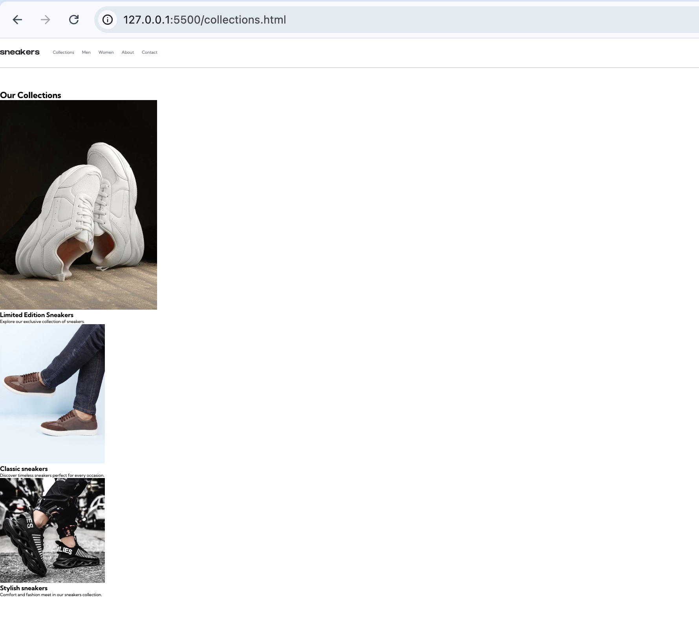

7. Men’s page:

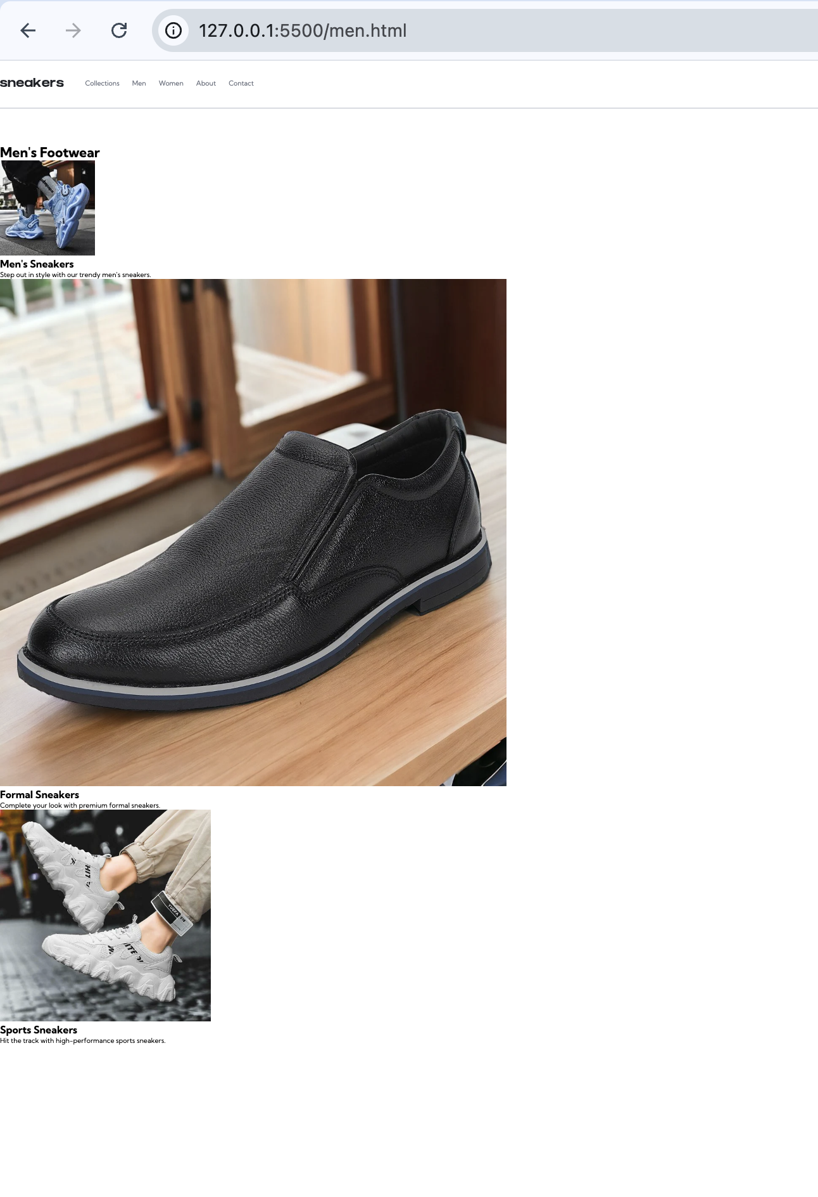

8. Women’s page:

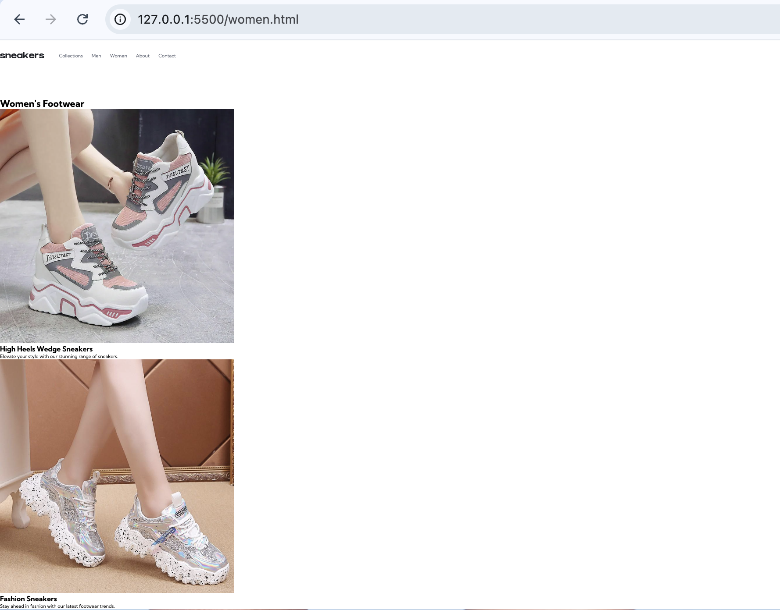

9. About page:

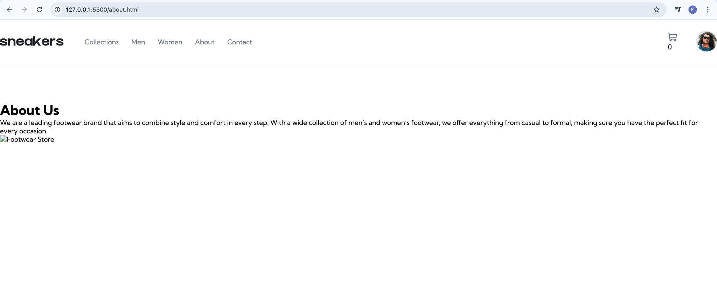

10. Contact us page:

